FULL ADDER

AIM: To perform fulladder using logicism.

INPUT:

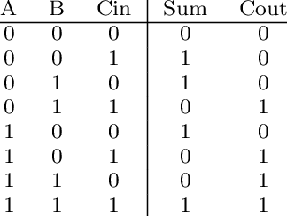

OUTPUT:

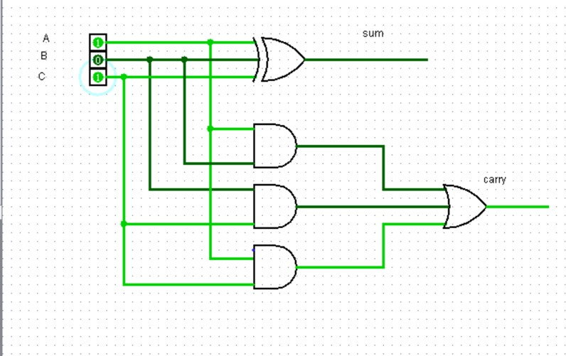

RESULT:

Thus full subtractor is executed successfully using logicism.